ADI SOYADI SINIFI NUMARASI 1

|  |
| --- |
| m= 3 kg |
| Δx= 160 metre |
| = 10 m/s |
|  |
| a= |

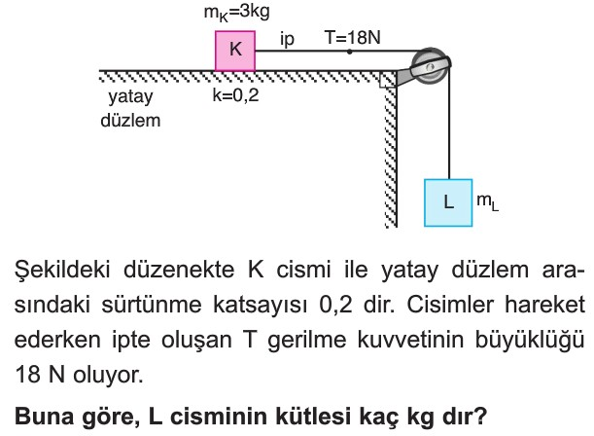

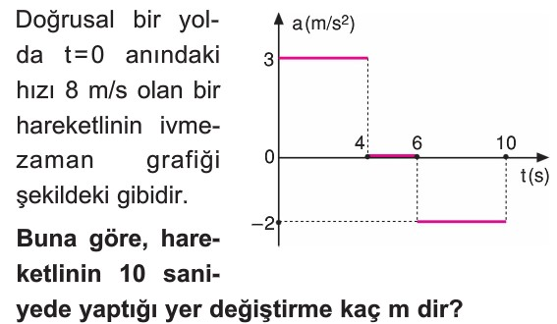2

3

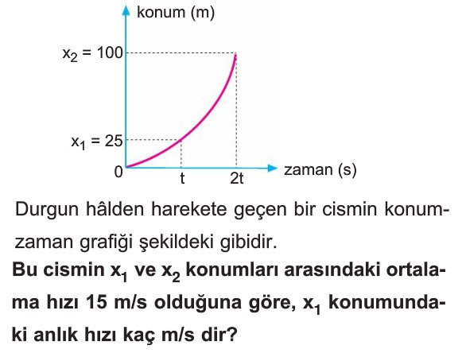

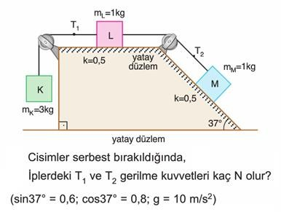4

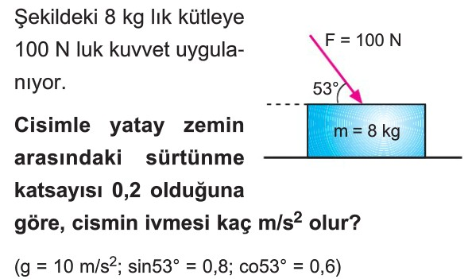

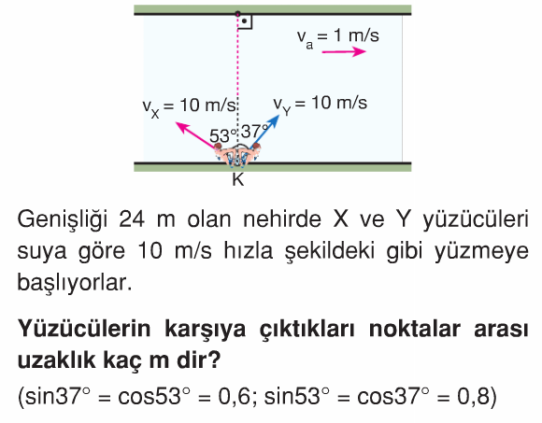6

|  |
| --- |
| Δx= 49 metre |
| R= √ |
| a= |
| = 5 m/s |
| F= 20 NEWTON |

7

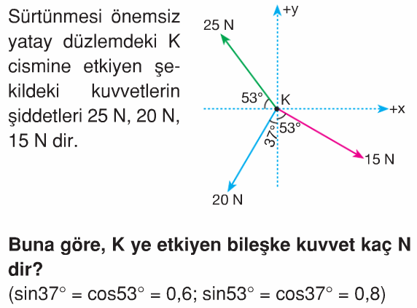

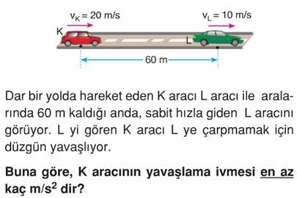8

9

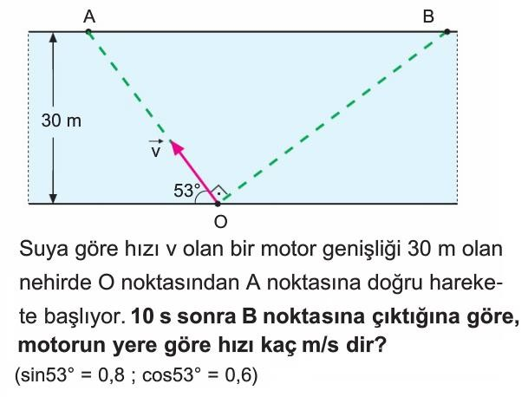

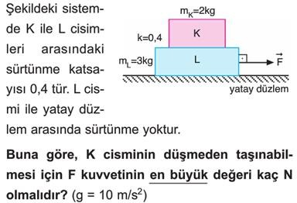10



*ENGİN BÜYÜKÇELEBİ*