Name:

Surname:

No:

*TAVŞANLI TECHNICAL HIGH SCHOOL 2017-2018 1st TERM 2nd ENGLISH EXAM FOR ATL11-A*

*QUESTIONS*

1. ***Read the text and answer the questions. (Parçayı oku, boşlukları doldur ve soruları cevapla)*** *(6x2=12p)*

The most powerful earthquake hit Japan on Friday March, 2011 at 2:26 p.m local time. The earthquake was 8.9 magnitude. A huge tsunami followed the earthquake. The waves reached six miles on Japan’s northeast coast. The fall of water swept away cars, ships and buildings. The earthquake and tsunami caused extensive damage and there were thousands of deaths and hundreds of missing people. In Tokyo people screamed and grabbed each other’s hands when the quake hit. The shock was so powerful that even the people in Beijing felt it.

1. Where did the earthquake occur? ..............................................................................
2. When did it happen? ..............................................................................
3. What was the magnetidu of the earthquake? ..............................................................................
4. What happened after the earthquake? ..............................................................................
5. Why were there thousands of deaths? ..............................................................................
6. Did the people in Beijing feel the earthquake? ..............................................................................
7. ***Match the words with their meanings. (kelimeleri anlamları ile işleştiriniz.)*** (7x2=14p)

i. extensive(adj.) a. covering or affecting a large area. i. ........

ii. sweep (v) b. the force of an earthquake. ii. ........

iii. hit(v) c. give a long cry. iii. ........

iv. scream(v) d. couse a damage suddenly. iv. ........

v. grab (v) e. remove in a fast and powerful way. v. ........

vi. huge (adj) f. hold suddnly. vi. ........

vii. magnitude (n) g. very big enormous. vii. ........

1. ***Choose the right adjective and write it into the blank. (Doğru sıfatı seçip yazınız.)*** (10x1=10p)

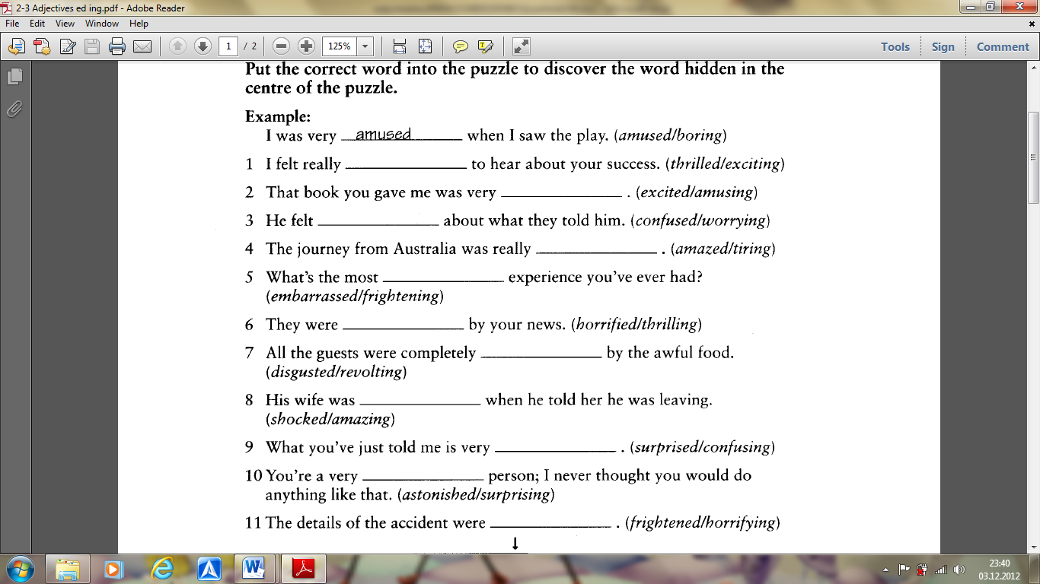

1. ***Write the verbs under the pictures. (kutudaki fiilleri resimlerin altına yazınız.)*** (12x1=12p)

paint hoover play tennis play the guitar dance cycle

brush/ teeth listen to music set the table surf watch tv cook

|  |  |  |  |  |  |
| --- | --- | --- | --- | --- | --- |
| 1/.......................  ........................ | 2/..................... | 3/..................... | 4/..................... | 5/..................... | 6/..................... |
| 7/..................... | 8/..................... | 9/..................... | 10/.................. | 11/........................................... | 12/.................... |

1. ***Look at the pictures above and write what they did yesterday. (Resimdeki insanların dün ne yaptığını yazınız.)*** (12x1=12p)

1/ Lea ..................................................................

2/ Susan ................................................................

3/ Bob and his dog .............................................

4/ Steve .............................................................

5/ Rachel ...........................................................

6/ Mrs Smith ....................................................

7/ Mary ...............................................................

8/ Max ...............................................................

9/ Bruce .............................................................

10/ The children .............................................

11/ Bill ................................................................

12/ Vanessa ..............................................................

1. ***Add the appropriate articles a/an/the to the words listed below. (boşlukları a-an-the ile doldurunuz.)*** (10x1=10p)

1. Where did you have ............. lunch? 6. We went to ................. theatre.

2. We went to ............... restaurant. 7. I play ............. football.

3. Do you go to ............... cinema very often? 8. She listens to ............. radio

4. I had ............... dinner at 7. 9. He watched ............ TV last night

5. Please turn off ................TV? 10. There is a programme on ........ radio.

1. ***Write the best modal “ must,mustn’t, have to, don’t have to needn’t. (Uygun modal’ı yazınızz)*** (10x1=10 p)

1. You________________ touch electric wires with wet hands.

2. I __________________ to study hard if I want to pass my exams.

3. She________________ go to the market if she is tired.

4. He_________________ visit the dentist at least once a year.

5. Kids_______________ go to school after the age of 16.

6. You _______________drive on the right in Spain.

7. You _______________ get up or youl’ll be late!

8. My father ____________ smoke that much.

9. They _________________go if they don’t want to.

10. I________________ hurry or I’ll miss the train.

1. **Complete the sentences with the comparative or superlative form of the adjectives in brackets.** (10x2=20p)

1.- My sister is ________________________ my brother. (intelligent)

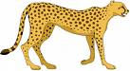2.- The blue whale is ________________________ animal. (big)

3.- Iceland is ________________________ Spain (cold)

4.- This is ________________________ book I’ve ever read. (good)

5.- My neighbour is ________________________ person I know (lucky)

6.- Friday is the ________________________ day of the week. (busy)

7.- These trainers are much ________________________ those. (cheap)

8.- The cheetah is ________________________ animal in the world. (fast)

9.- I’m ________________________ at English than you. (good)

10.- Today has been ________________________ day of the year. (hot)

T H E E N D



Good Luck!



Bad luck for one man is

good luck for another.

Metin AKKAN

Teacher of English