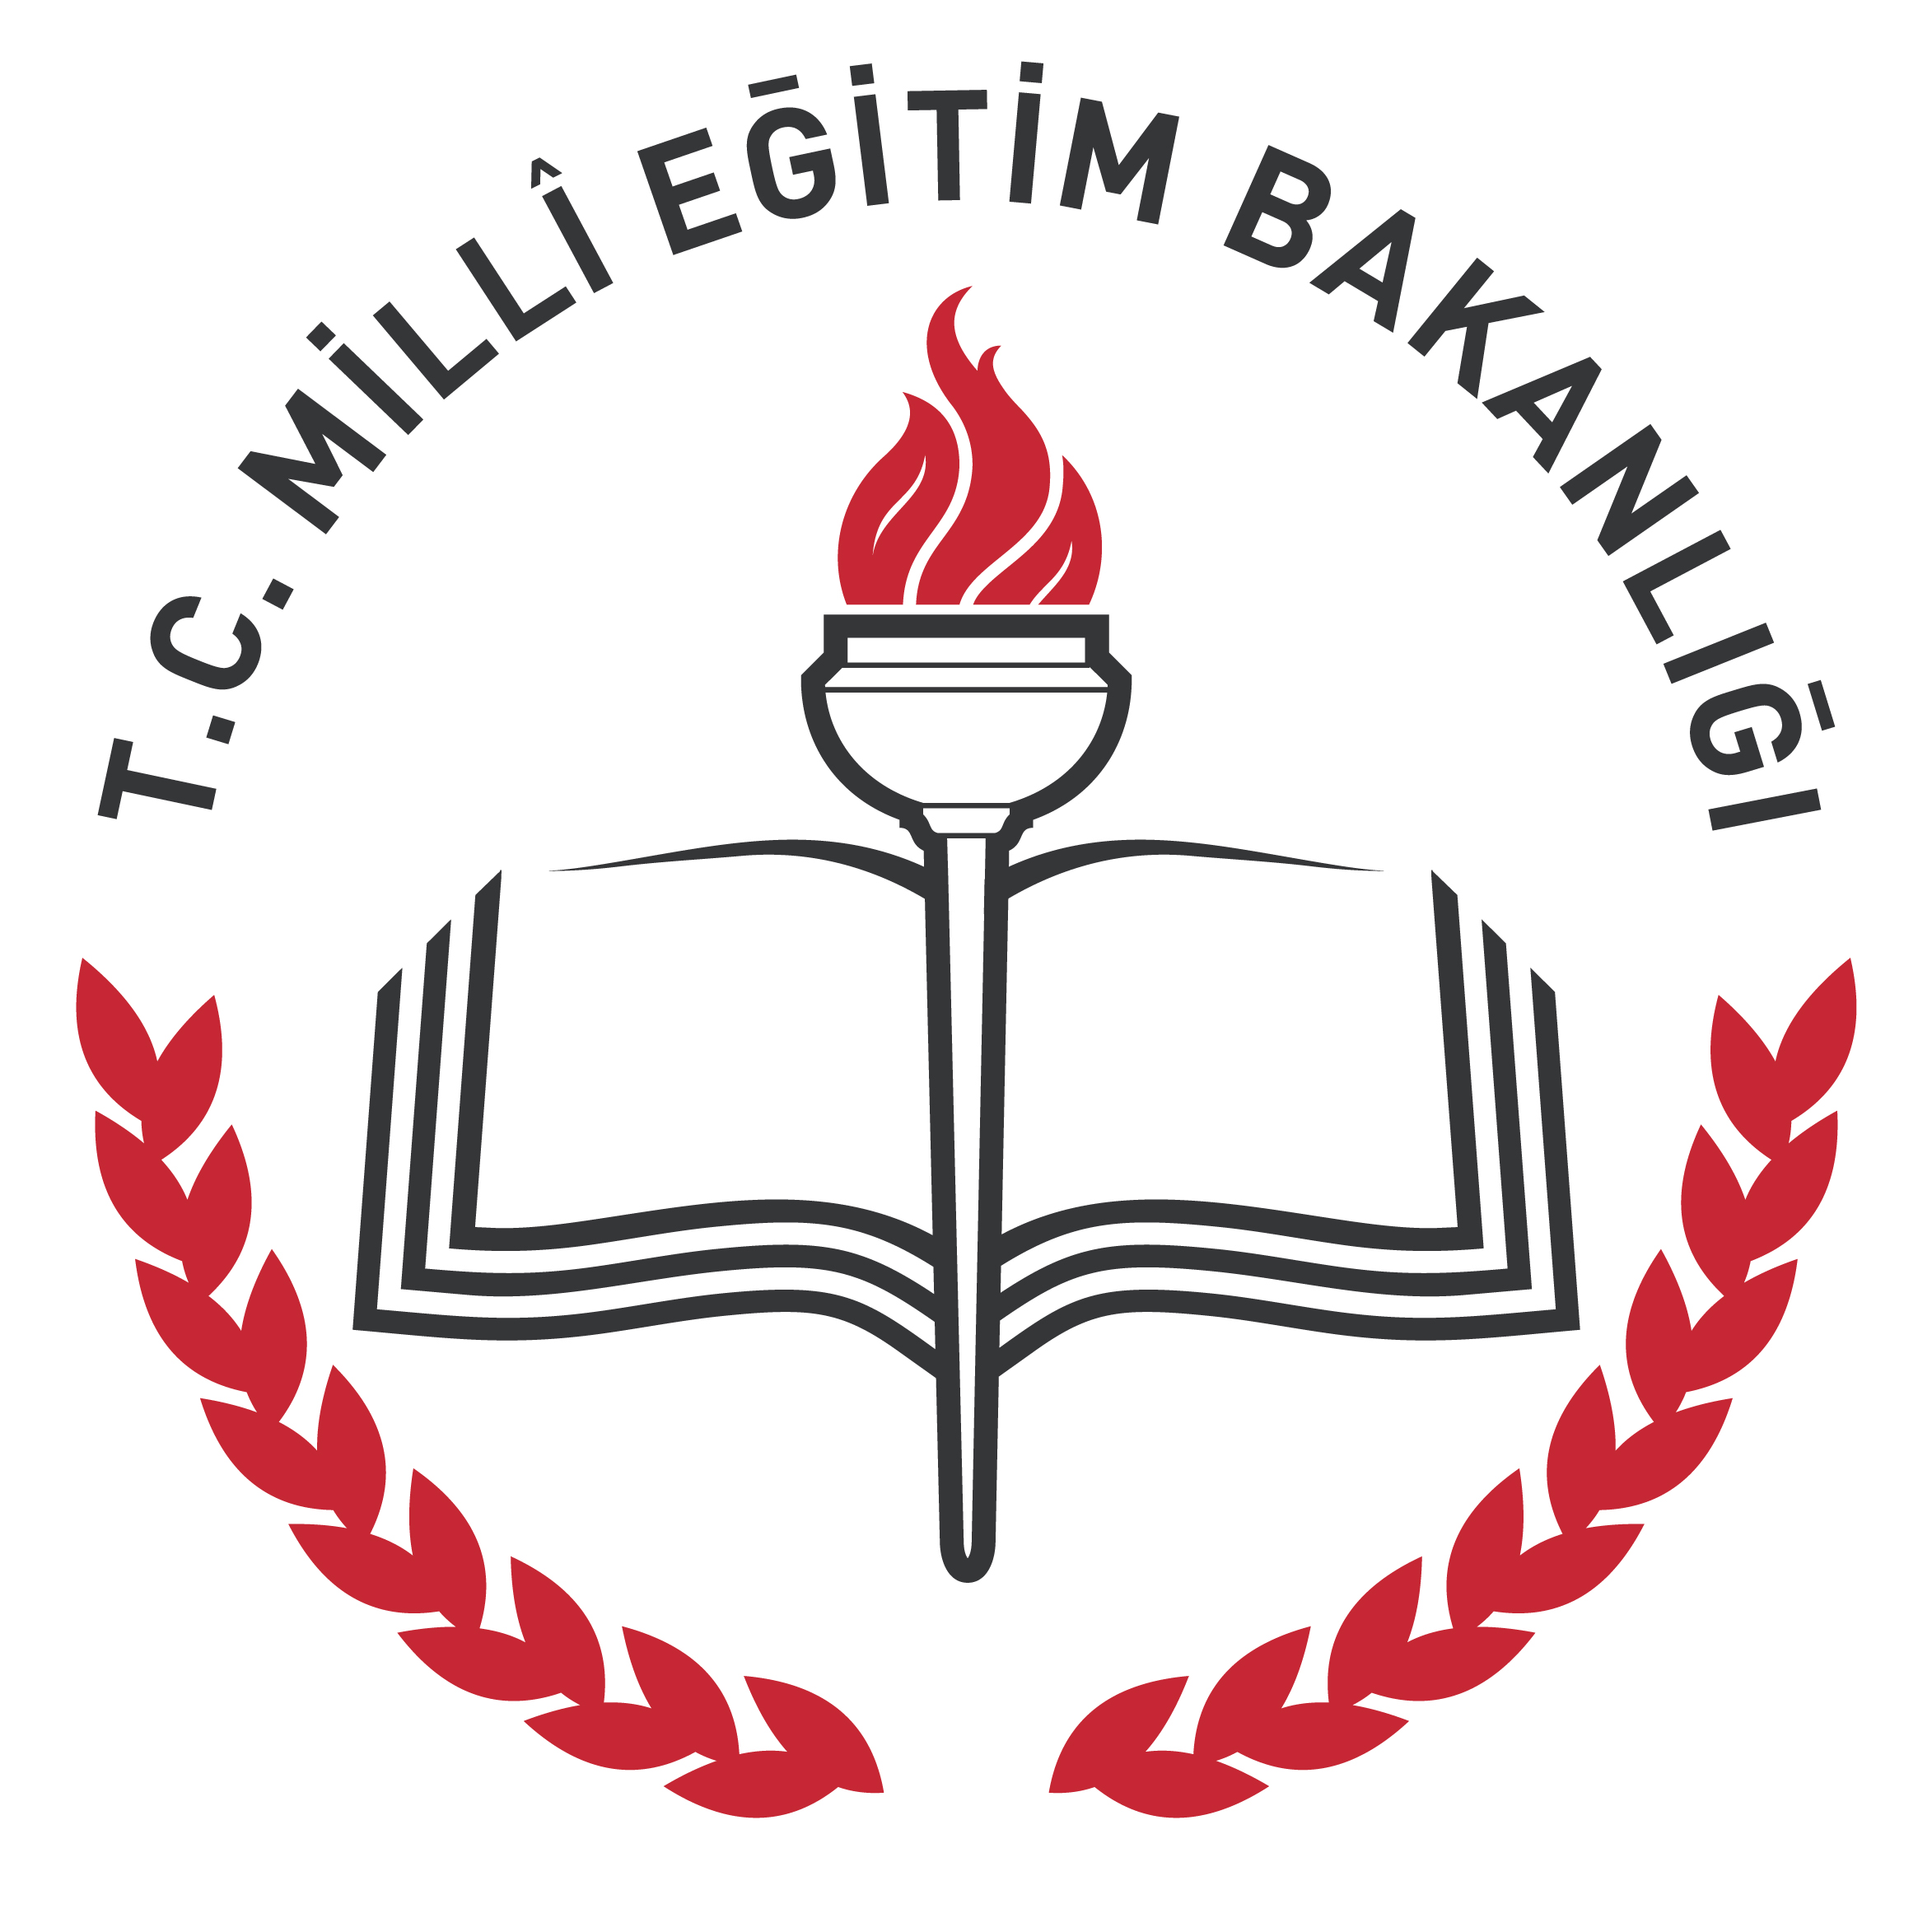
HALİL TURKKAN ANATOLIAN HIGH SCHOOL 2017-2018 ACADEMIC YEAR 2nd TERM 2st ENGLISH PRACTICE EXAM for 11-B

Full Name: Class – Number:

READING (25 PTS)
A)Read the text and put the dialogs in an order.(1 to 7) (7x=7 pts)

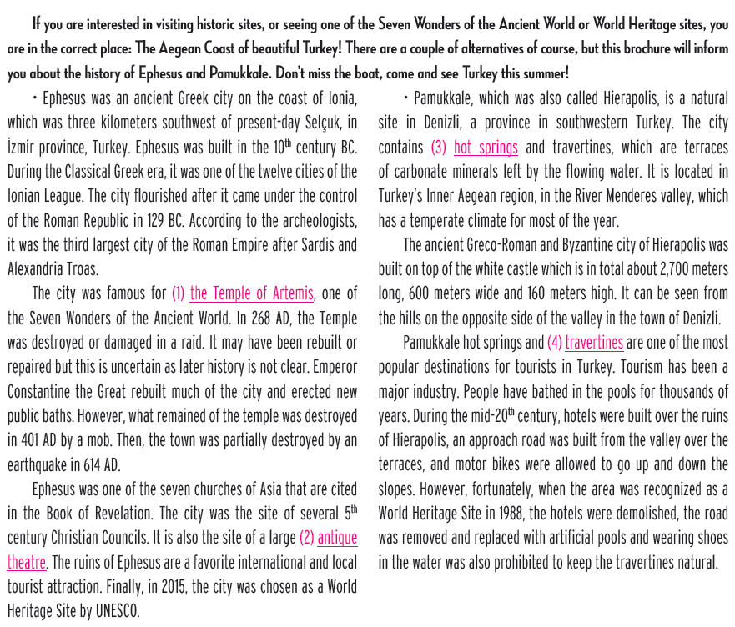

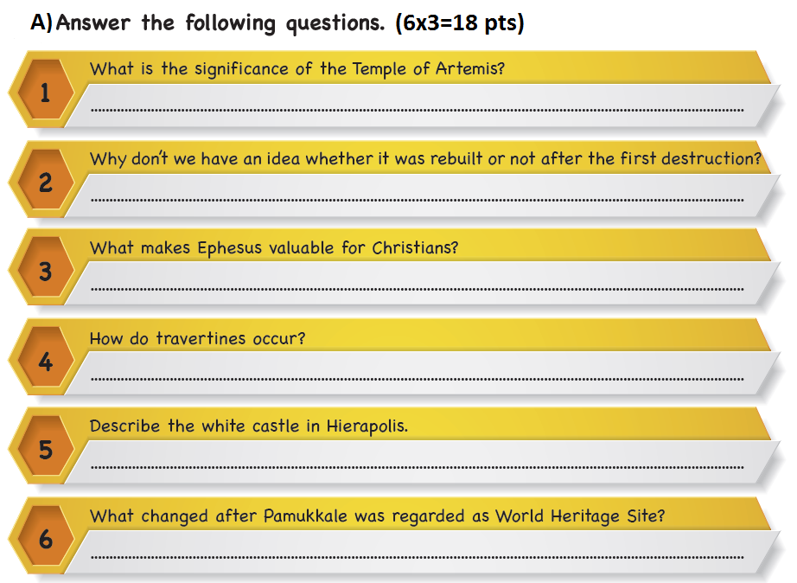

B) Write Turkish meanings of words the below (7x1=7 pts)
coast: heritage: contain: prohibit:
temple: rebuit: demolish:

WRITING (25 PTS)
Write a paragraph about your “What if…” situations (10 sentences) (10x2,5 = 25 pts)

LISTENING (25 PTS)

Listen and answer the following questions.

1)When can’t you visit Topkapı palace?(4 pts)

2)How much is a museum ticket? (4 pts)

3)Where can the tourist buy some presents? (4 pts)

4)How can the tourist g oto Topkapı Palace? (5 pts)

5)How many days will the tourist stay in İstanbul? (4 pts)

6)Where will the tourist go after İstanbul? (4 pts)

GOOD LUCK Salih ÇİVİ
English Language Teacher

