………………..HIGH SCHOOL 2017-2018 EDUCATION YEAR 1st TERM 2nd WRITTEN ENGLISH EXAM
LEVEL: (A2.3)
NAME AND SURNAME : ………………………………………………… NUMBER : …………………………….
A)Fill in the blanks with “can - can’t – must - mustn’t - don’t have to,have to”(6x3=18 p)
1- She is a small baby. She ……………….….. (eat )meat, but she ……………….…… (drink) milk.
2. .I ……………………………………get a new passport to go abroad
3-We …………………………………. (not / pick) the flowers in the park.It is prohibited!
4-Tomorrow is Saturday. We…………………………………………(not/go) to school.
5. It’s raining heavily. You …………………….………… (take) your umbrella.
B) Aşağıdaki kelimeleri kullanarak cümleleri uygun bir şekilde tamamlayınız.(2x5=10P)
local - globe - experience - colloquial - qualifications

1. My students want to understand.............................. English and they watch TV serials in English.
2. My grandma is over 90 years old and she has a lot of life...................................
3. .............................. people in villages are very welcoming in Turkey.
4. You need to have good...................................for a good job.
5. China exports goods all over the......................................
C)Parantez içindeki fiilleri Simple Past Tense olarak doldurunuz.(1x15=15 points)

Last night I ……………………..…… (go) to my favorite restaurant in West Street. I …………….……….. (leave) the restaurant at about 11 o’clock. It ………………………..….. (not/be) a cold evening so I ……………..………….. (decide) to walk along the beach.

Suddenly, I ………......................………… (hear) a noise. I ……….....................……….. (turn) and …….....................………… (see) three boys aged about eighteen. One boy ……………....................… (come) up to me and …………..........…….. (ask) me the time. When I looked down at my watch, he ……………… (hit) me and I ………................……… (fall) to the ground. Another boy ………................………. (take) my wallet. I ……….......................……….. (not/shout) for help because I ....................................(be) afraid of them.Then they …….........................…………(run) away.
D)This is your classmates’ media habits for last week.Write sentences: (3x5=15p)
%30 newspaper 1-…………………………………………………………………………………………….
%60 TV 2-……………………………………………………………………………………………
%5 letter 3-………………………………………………………………………………………….
%60 Internet 4-…………………………………………………………………………………………
%25 magazines 5-…………………………………………………………………………………………..
E)Correct the mistakes: (6x2=12p)
1-I buy a new car yesterday. ……………………………………………………………………
2-He didn’t drank milk last night……………………………………………………………..
3-Who did you invited for the party? ………………………………………………………..
4-Who did wash the dishes at camp?..........................................................
5-What time does he leave school yesterday?............................................
6-I eat ice cream two hours ago………………………………………………………………….
F)Look at the map! Find the names of the places: (3x5=15p)
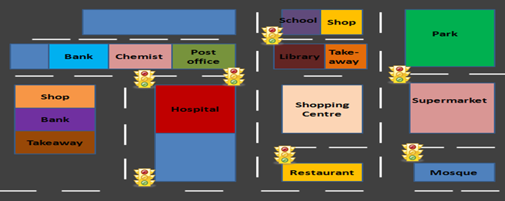
1.Where is the chemist? ……………………………………………………………………
2.Where is the library?........................................................................
3.Where is the school?.......................................................................
4.Where is the restaurant?................................................................
5.Where is the bank?.........................................................................
G) Complete the sentences meaningfully : (3x5=15p)
1-I watched a horror film but ………………………………………………………………………………
2.I drank cold water and ………………………………………………………………………………………..
3.She went to shopping yesterday because……………………………………………………………
4.My mother was very ill so …………………………………………………………………………………..
5.I did not want to go to party because …………………………………………………………………

